Burton Beekeepers - Plan to Develop a Training Apiary
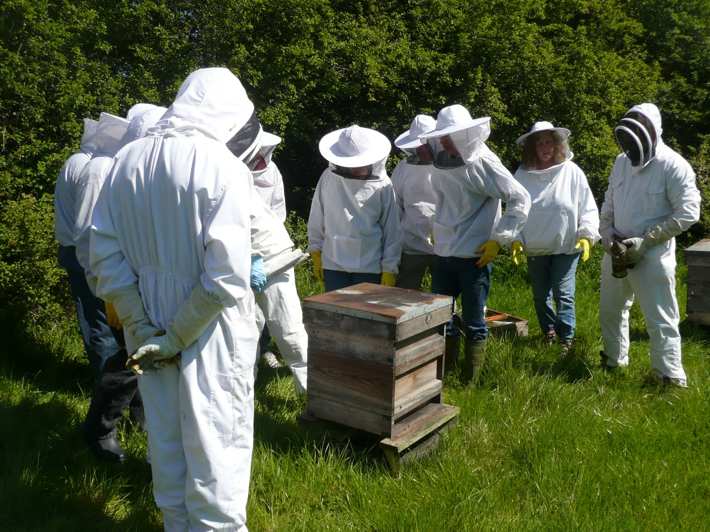

About Burton Beekeepers
Formerly known as the Burton Branch of the Derbyshire Bee Keepers Association our association was founded more than 60 years ago.
In recent years the association has grown steadily. It began holding regular monthly association meetings a few years ago and late in 2016 the members applied to the British Beekeepers Association (BBKA) to be recognized as a separate association. It was granted independent status at a BBKA general meeting on 14th January 2017.
The association is an unincorporated charitable association and has a hard-working committee of up to 10 members which normally meets six times a year to consider finances, and other association issues.

Constitutionally the Objectives of the Association are:
1. To promote and further the craft of beekeeping.
2. To provide education and assist members with all aspects of bee keeping, including bee health and keeping healthy bees.
3. To promote public awareness of the importance of honey bees and beekeeping.
In pursuit of these objectives we run occasional apiary meetings at members homes, study groups, and workshops. Members are encouraged to develop themselves in beekeeping skills and knowledge by practicing new techniques and taking exams run by the British Beekeepers Association. Occasionally we organize open education days which can be attended by beekeepers from other local associations. These days cover a variety of topics but disease recognition and management is high on the priority list. We also have a comprehensive library where members can have a book on loan, so education doesn’t have to be expensive and out of reach for anyone.
To promote public awareness, we have a close relationship with Burton’s Coopers Square shopping centre, where we keep (on the roof) a small apiary. We hold annual events in Coopers Square and regularly have stands at local country shows such as Ashbourne, Alrewas, Barton under Needwood. In common with many other beekeeping associations we advise members of the public on bees and are often called out to deal with swarms.

Decision to develop a training apiary
Most beekeeping associations have their own teaching apiary. Derbyshire (Burton’s previous parent association) has one but it is unsatisfactory for Burton Beekeepers particularly as it is a considerable distance from Burton. It was not attended by Burton members. Becoming an independent association has meant that Burton Association Members cannot, as of right, attend classes at the Derby apiary without becoming associate members of the Derby Association.
Establishing our own training apiary follows naturally from our becoming independent from Derby, and is a key development need for the Association in 2018.

What are the benefits of having our own training apiary.
Anyone can of course start beekeeping by reading a book, acquiring some bees, and popping them in the orchard at the bottom of the garden. An experienced beekeeper will tell you though that the skill takes many years to learn, and there are lots of pitfalls along the way.
Controlling disease and avoiding malnutrition have become a special challenge in recent years and lots of experience and knowledge are needed just to keep a colony alive and well, let alone produce honey from it.
In common with other practical skills like Pottery, Sewing, and Painting, learning the craft of Beekeeping, is much easier in the company of more experienced people. This is because all the right questions come to mind when you are doing a key manipulation yourself with a tutor by your side. A training apiary therefore gives much needed “hands on” experience and leads to much better beekeeping, in a shorter time.
In addition:
- Many people are interested in learning about beekeeping but either don’t have room for their own hives at home, or aren’t sure whether to commit themselves by getting their own bees. Without the confidence which will come from working with an experienced beekeeper these people will quickly lose interest.
- Bees are venomous insects and a sting is quite painful. For some people there is a need to build up confidence over a considerable time before starting on their own.
- It is a sad fact that most beekeepers are older. Younger people need to be encouraged to take up the craft. For any young person, taking up beekeeping is more difficult than it is as an adult, because of the many things competing for their interest and the shortage of space at home. A good introduction through practical classes is an excellent way of getting younger people interested.
- The skills of experienced beekeepers may stagnate after a time. Teaching others is a strong stimulus to keeping up to date and honing skills which may have become rusty.

Formation of this Plan
In September 2017 a small project team was formed from Committee members, we visited 4 training apiaries of different sizes in Leek, Stoke, Birmingham and Solihull. The range of facilities and activities undertaken at each is quite considerable, but the experience gave our project team very clear ideas about what our model apiary will look like and how it will be run.

Finding the right site
The economics of beekeeping are such that money just isn’t available to acquire or rent land for this purpose. Most training apiaries are sited on unused land which has been made available by a local landowner.
Inevitably the final choice of site will be influenced by the opportunities which present themselves after the project gets fully under way but the key features which we will be looking for are:
- The site should be within reasonably easy reach of Burton
- Ideally it will be possible to park plenty of cars nearby
- The size of the site will be at least 300 – 500 M2
- It must have easy access to bring in and take away equipment (possibly also visitors in wheelchairs).
- It should be easy to keep tidy and secure from vandals and large animals (Cattle can sometimes destroy colonies quite quickly).
- Bees are venomous insects. The site’s location should not create a risk to the general public.
- The conditions of our use will of course be what the landowner wants to lay down. This said, moving to another plot will be a significant undertaking and we would want to be reasonably confident that the association can rely on the free use of the plot for a reasonable time.
Other Facilities:
- We will need to erect a small building to store equipment
- Ideally there will be a water supply
- Toilet facilities and a place where we could hold classes are desirable but not essential.
Once this plan is completed and agreed by Committee, a small group will begin approaching local landowners and ask them to consider allowing the association to use a plot of their land for this purpose.

Organization and Timing
Until a plot of land has been agreed on and access granted, detailed plans regarding the further actions to be taken will have to remain very fluid. The Budgets and Project plan which will be the subject of discussion at the forthcoming AGM could therefore change, nevertheless they are strongly indicative of the approach which will be taken and the intended timing.

